1️⃣ Project Overview
The Community Task & Volunteer Coordination Platform is a web-based system designed to connect volunteers with community activities in an organized and structured way.
The platform allows administrators to create and manage activities, while volunteers can browse available opportunities and apply to participate. The system manages approvals, tracks volunteer participation, and maintains accurate records of activities and users.
The main objective of the system is to improve coordination efficiency, reduce manual processes, and provide a transparent and scalable solution for managing community engagement.

2️⃣ Problem Definition
Currently, volunteer opportunities are often shared through social media posts, messaging groups, or informal communication channels. This leads to several issues:
- No centralized platform to organize activities
- Difficulty tracking volunteer participation
- Manual approval processes
- Lack of historical records
- Risk of data loss or miscommunication
As a result, both volunteers and organizers face inefficiencies and confusion.
This project aims to solve these issues by providing a centralized digital platform that ensures structured management of users, activities, and assignments.

3️⃣ Functional Requirements

User Management
- Users can register and create an account.
- Users can log in securely using email and password.
- The system assigns roles (Admin / Volunteer).
- Users can update their profile information.
- Admins can suspend or deactivate users.

Activity Management
- Admins can create new activities.
- Admins can edit or delete activities.
- Each activity must include name, description, location, date, and expected volunteers.
- Activities can have different statuses (Open, Closed, Cancelled).
- The system tracks creation and update timestamps.

Volunteer Assignment
- Volunteers can browse available open activities.
- Volunteers can apply to participate in an activity.
- The system prevents duplicate applications.
- Admins can approve or reject volunteer applications.
- The system stores sign-up date and assignment status.
- The system maintains a relationship between users and activities.

Data Integrity
- Each user has a unique email.
- Foreign key relationships ensure referential integrity.
- The system enforces role-based permissions.

4️⃣ Non-Functional Requirements

Security
- Passwords must be stored securely (hashed).
- Role-based access control must be enforced.
- The system must prevent unauthorized data access.

Performance
- The system should respond within 2 seconds under normal load.
- The system should support at least 100 concurrent users.

Reliability
- The system should ensure data consistency.
- Database constraints must prevent invalid data.
- The system must handle errors gracefully.

Usability
- The interface should be simple and intuitive.
- Users should be able to navigate easily between pages.
- Error messages should be clear and informative.

5️⃣ System Scope

Included
- User registration and authentication
- Role management (Admin / Volunteer)
- Activity creation and management
- Volunteer application management
- Assignment approval workflow
- Database design and ERD
- SQL schema implementation

Not Included
- Payment system
- Mobile application
- Messaging or chat system
- Email notification system
- External API integrations

ERD+SQL

CREATE TYPE user_role AS ENUM ('admin', 'volunteer');

CREATE TYPE user_status AS ENUM ('active', 'inactive', 'suspended');

CREATE TYPE activity_status AS ENUM ('open', 'closed', 'cancelled');

CREATE TYPE assignment_status AS ENUM ('pending', 'approved', 'rejected');

جدول المستخدمين (User)

CREATE TABLE "User" (

user_id SERIAL PRIMARY KEY,

first_name VARCHAR(50) NOT NULL,

last_name VARCHAR(50) NOT NULL,

email VARCHAR(100) UNIQUE NOT NULL,

phone VARCHAR(20),

password VARCHAR(255) NOT NULL,

role user_role DEFAULT 'volunteer',

status user_status DEFAULT 'active',

created_at TIMESTAMP DEFAULT CURRENT_TIMESTAMP,

updated_at TIMESTAMP DEFAULT CURRENT_TIMESTAMP

);

جدول الأنشطة (Activity)

CREATE TABLE Activity (

activity_id SERIAL PRIMARY KEY,

creator_id INT NOT NULL,

name VARCHAR(150) NOT NULL,

description TEXT,

location VARCHAR(255),

date TIMESTAMP NOT NULL,

expected_volunteers INT NOT NULL DEFAULT 0,

status activity_status DEFAULT 'open',

created_at TIMESTAMP DEFAULT CURRENT_TIMESTAMP,

updated_at TIMESTAMP DEFAULT CURRENT_TIMESTAMP,

CONSTRAINT fk_creator FOREIGN KEY (creator_id)

REFERENCES "User"(user_id) ON DELETE CASCADE

);

جدول التسجيل (Assignment)

CREATE TABLE Assignment (
assignment_id SERIAL PRIMARY KEY,

activity_id INT NOT NULL,

volunteer_id INT NOT NULL,

status assignment_status DEFAULT 'pending',

sign_up_date TIMESTAMP DEFAULT CURRENT_TIMESTAMP,

CONSTRAINT unique_volunteer_activity UNIQUE(activity_id, volunteer_id),

CONSTRAINT fk_activity FOREIGN KEY (activity_id)

REFERENCES Activity(activity_id) ON DELETE CASCADE,

CONSTRAINT fk_volunteer FOREIGN KEY (volunteer_id)

REFERENCES "User"(user_id) ON DELETE CASCADE

);

INSERT INTO "User" (first_name, last_name, email, password, role) VALUES
('Ahmad', 'Ali', 'ahmad@example.com', 'hash_123', 'admin'),
('Sara', 'Salem', 'sara@example.com', 'hash_456', 'volunteer');
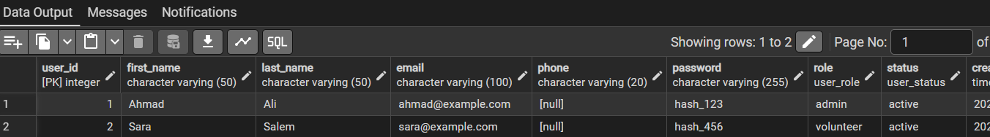
2. إضافة نشاط (بواسطة الأدمن Ahmad صاحب ID 1)
INSERT INTO Activity (creator_id, name, description, location, date, expected_volunteers)
VALUES (1, 'Clean the Beach', 'Environmental cleanup event', 'Gaza Coast', '2026-05-10 09:00:00', 20);
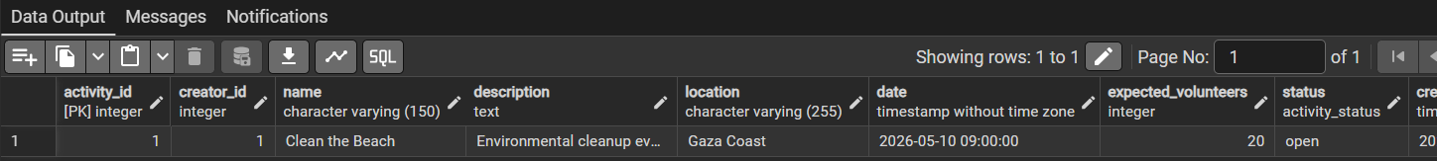

-- 3. تسجيل المتطوعة Sara (ID 2) في النشاط (ID 1)
INSERT INTO Assignment (activity_id, volunteer_id, status)
VALUES (1, 2, 'pending');
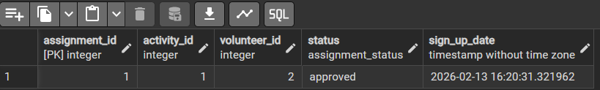
SELECT a.name AS activity_name, a.date, u.first_name AS creator_name
FROM Activity a
JOIN "User" u ON a.creator_id = u.user_id;
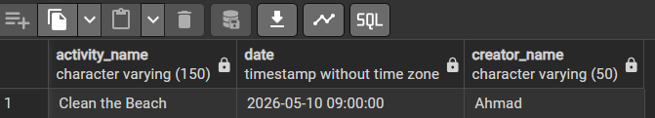
SELECT u.first_name, u.last_name, a.name AS activity_name, ass.status
FROM Assignment ass
JOIN "User" u ON ass.volunteer_id = u.user_id
JOIN Activity a ON ass.activity_id = a.activity_id;
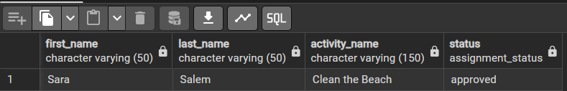

UPDATE Assignment
SET status = 'approved'
WHERE volunteer_id = 2 AND activity_id = 1;

SELECT a.name, COUNT(ass.assignment_id) as current_volunteers
FROM Activity a
LEFT JOIN Assignment ass ON a.activity_id = ass.activity_id
GROUP BY a.name;

